Judge a book



In this project, you will investigate whether it’s really possible to judge a book by its cover.

You will make a mobile app for a library assistant. When you point the app camera at a book, it will recommend the best shelf to put the book on, just from what the cover looks like.

To do this, you’ll need to train the computer to recognise book covers.

This project worksheet is licensed under a Creative Commons Attribution Non-Commercial Share-Alike License

http://creativecommons.org/licenses/by-nc-sa/4.0/

1. Go to <https://machinelearningforkids.co.uk/> in a web browser
2. Click on “**Get started**”
3. Click on “**Log In**” and type in your username and password  
   *If you don’t have a username, ask your teacher or group leader.  
   If you’ve forgotten your password, ask your teacher or group leader to reset it for you.*
4. Click on “**Projects**” on the top menu bar
5. Click the **“+ Add a new project**” button.
6. Name your project “judge a book” and set it to learn how to recognise “**images**”. Click “**Create**”  
   
7. You should now see “**judge a book**” in your projects list. Click on it.  
   
8. Click the “**Train**” button  
   
9. Choose a few types of books.   
   Imagine your app is going is to be used to help sort books in a library, and you need to think of a few shelves in your library.  
   *For the rest of this worksheet, I’ll be using:   
    “music”, “cookery”, and “childrens”.   
   Choose your own. Books that obviously look different will be easier for the computer to recognize.*
10. Use the “**+ Add new label**” button to create a bucket for each type of book you’re using.  
    Graphical user interface, text, application

    Description automatically generated
11. In another web browser window, find pictures of book covers.  
    *You need to find a website of pictures of book covers. This could be a library website, or a website that sells books. Find a site that arranges books by genre already to make it easier for you.*  
    *Resize the windows so your training buckets are next to the book site.*Graphical user interface, application

    Description automatically generated
12. Find pictures of book covers for each type that you chose.   
    Drag the best examples into the correct buckets in your training page.   
    *Try and find about 20 examples of each type.*   
    Graphical user interface, application

    Description automatically generated
13. Click the “**< Back to project**” link. Then click “**Learn & Test**”.
14. Click “**Train new machine learning model**”.  
    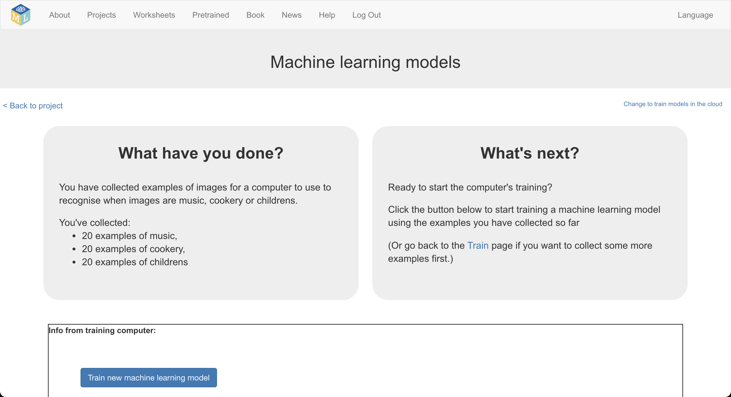
15. Try out your machine learning model to see if it is working  
    Find another picture of a book cover.   
    Make sure you use one that you didn’t use in the training.   
    Drag it into the test box where there is a space for a web address.  
    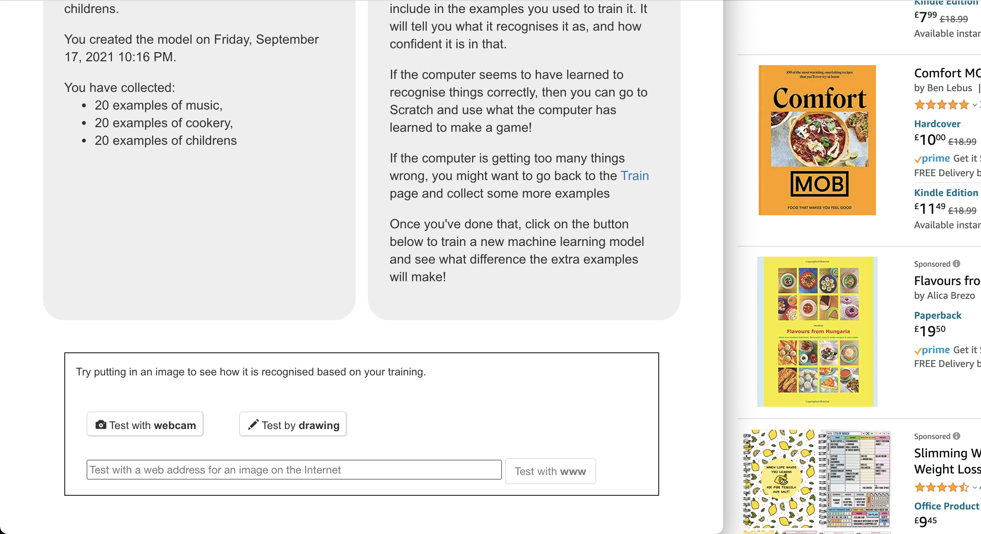
16. Click on “**Test with www**”  
    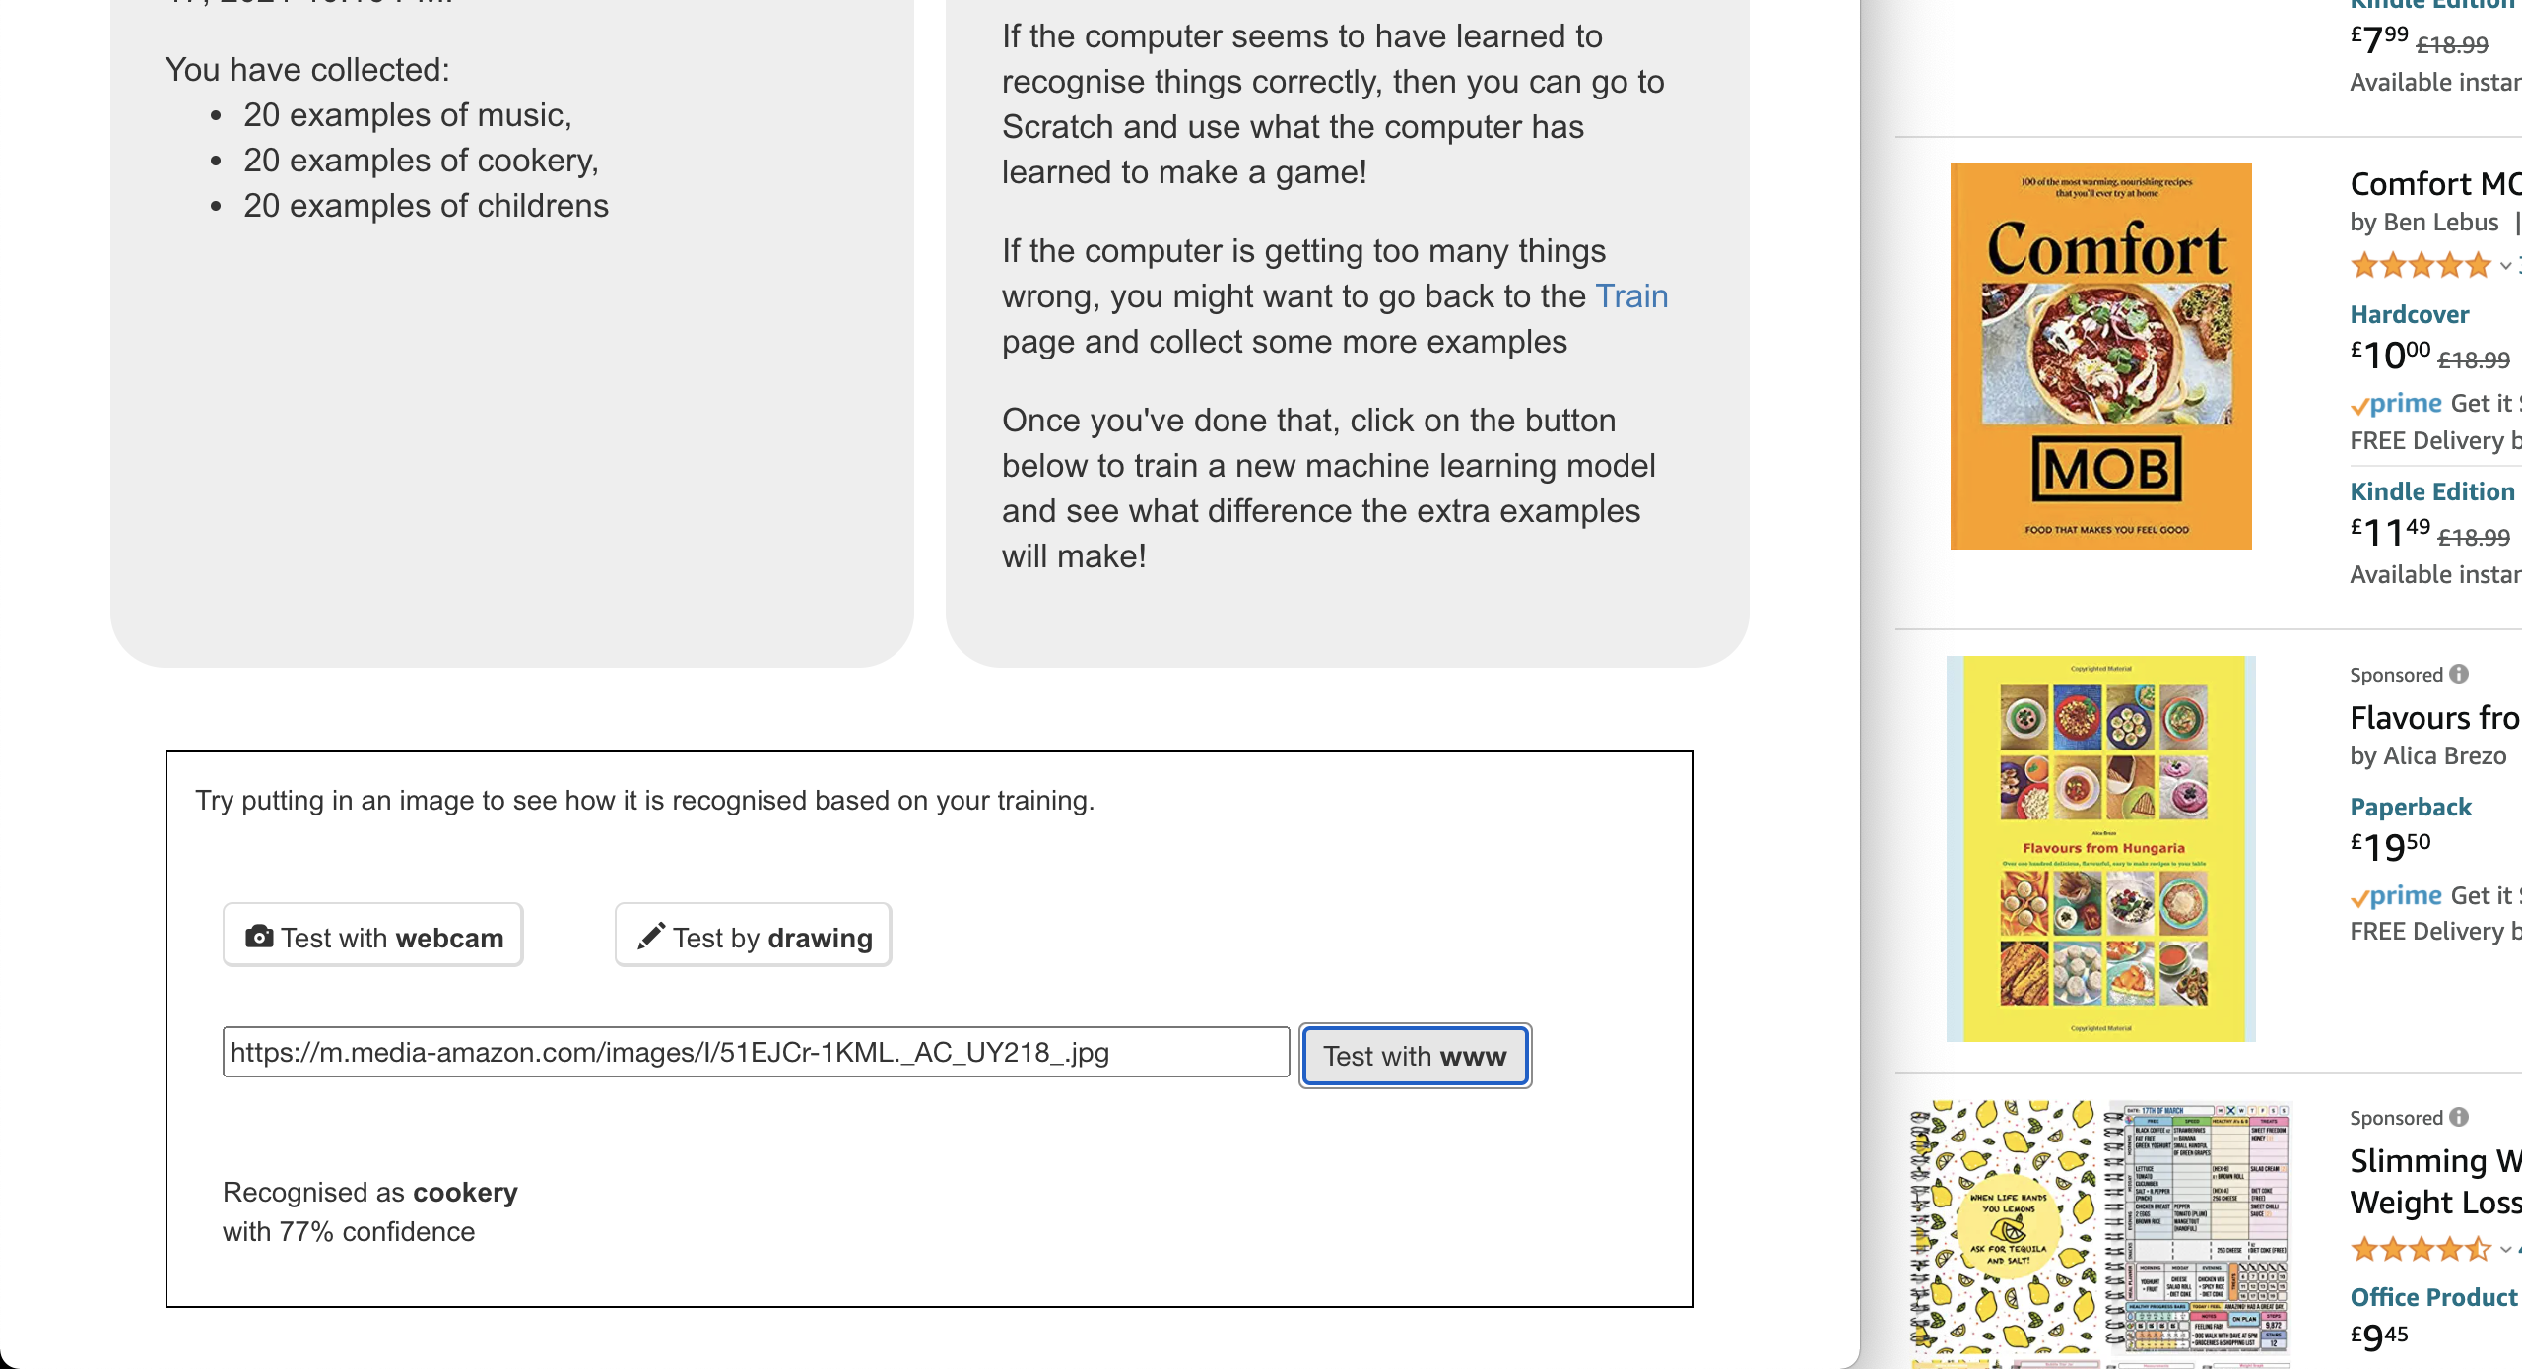
17. Try a few different book covers and see what your machine learning model has learned to recognize.  
    *If you’re not happy with the answers it is giving, go back to Step 12 and add more examples to your training buckets, then come back and train a new machine learning model.  
    When you’re happy, carry on to Step 18.*
18. Click on “**< Back to project**”
19. Click on the “**Make**” button  
    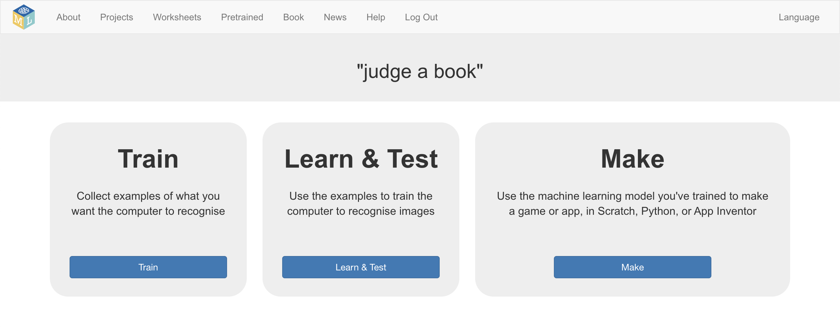
20. Click the “**App Inventor**” button  
    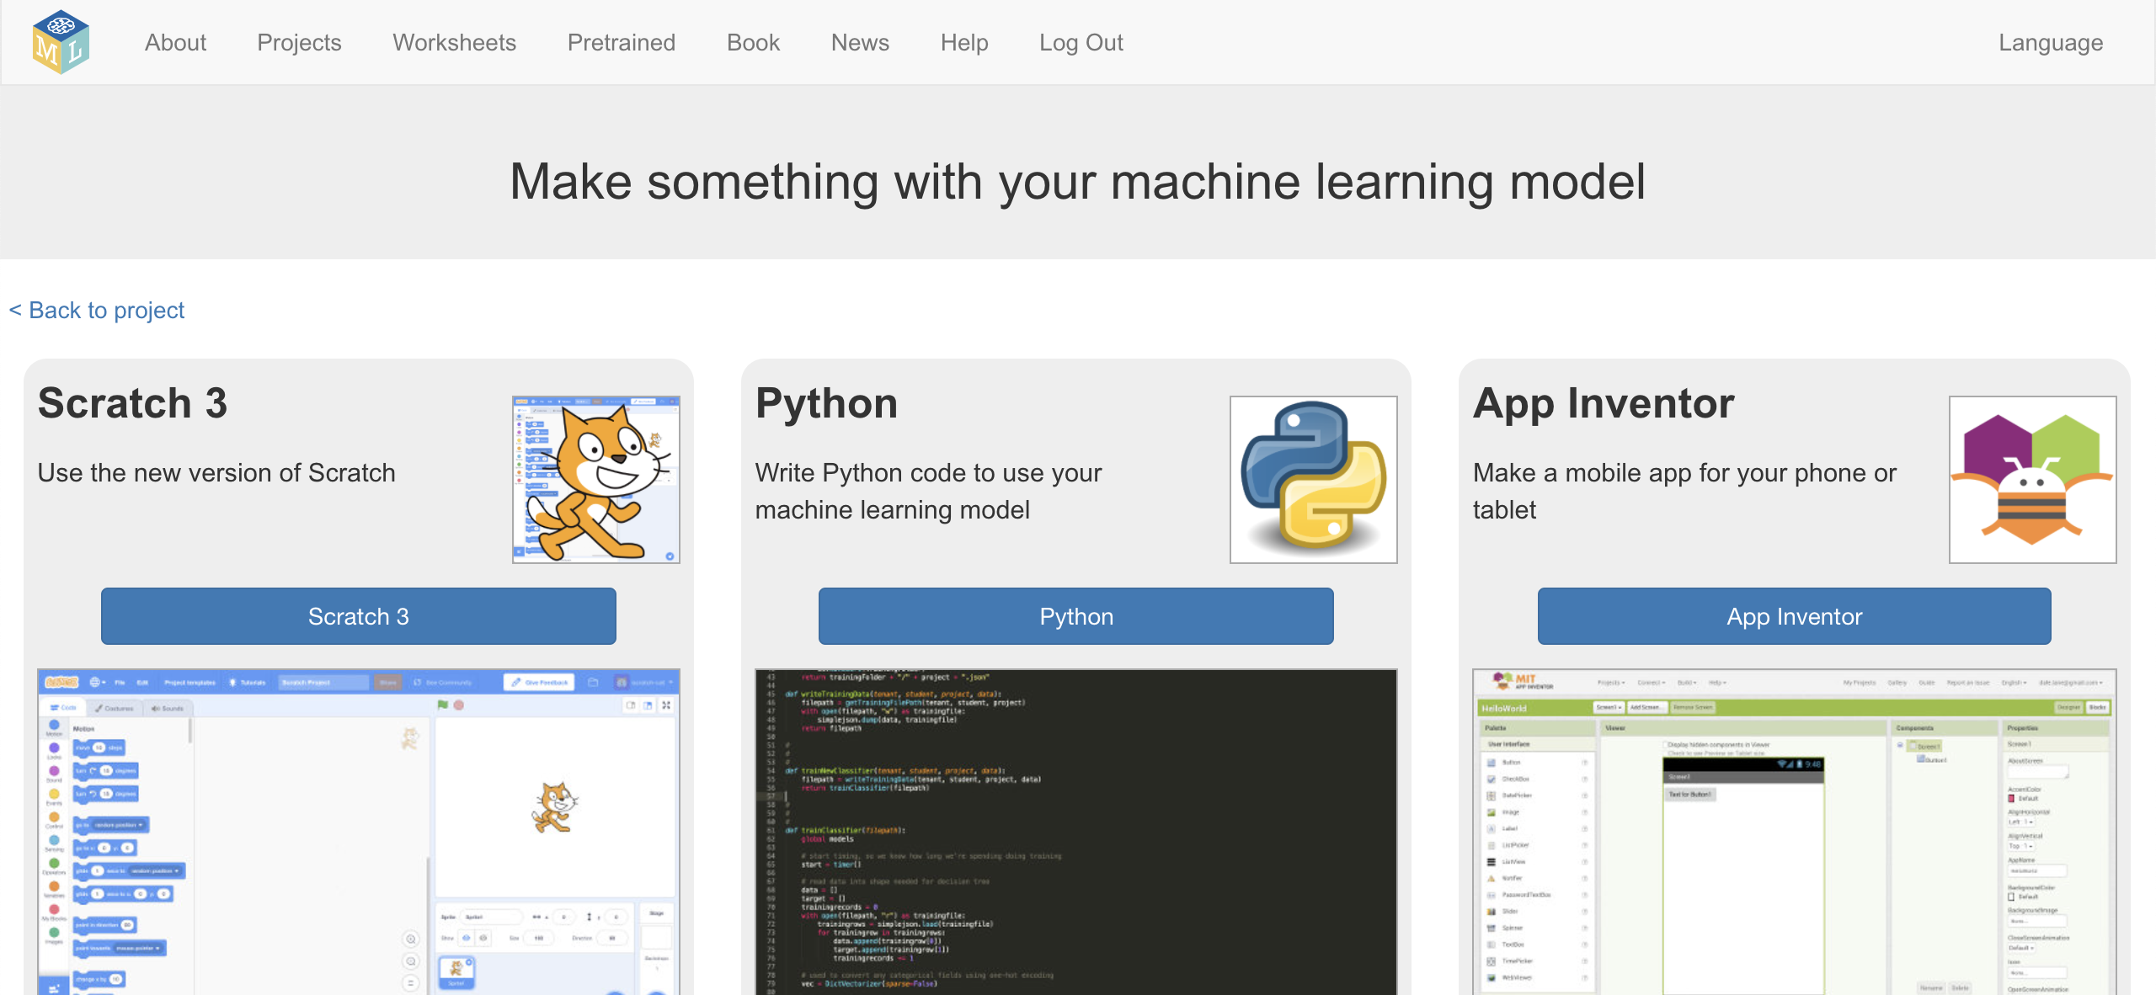
21. Copy the App Inventor extension address shown in red  
    *You’ll need this in a moment*  
    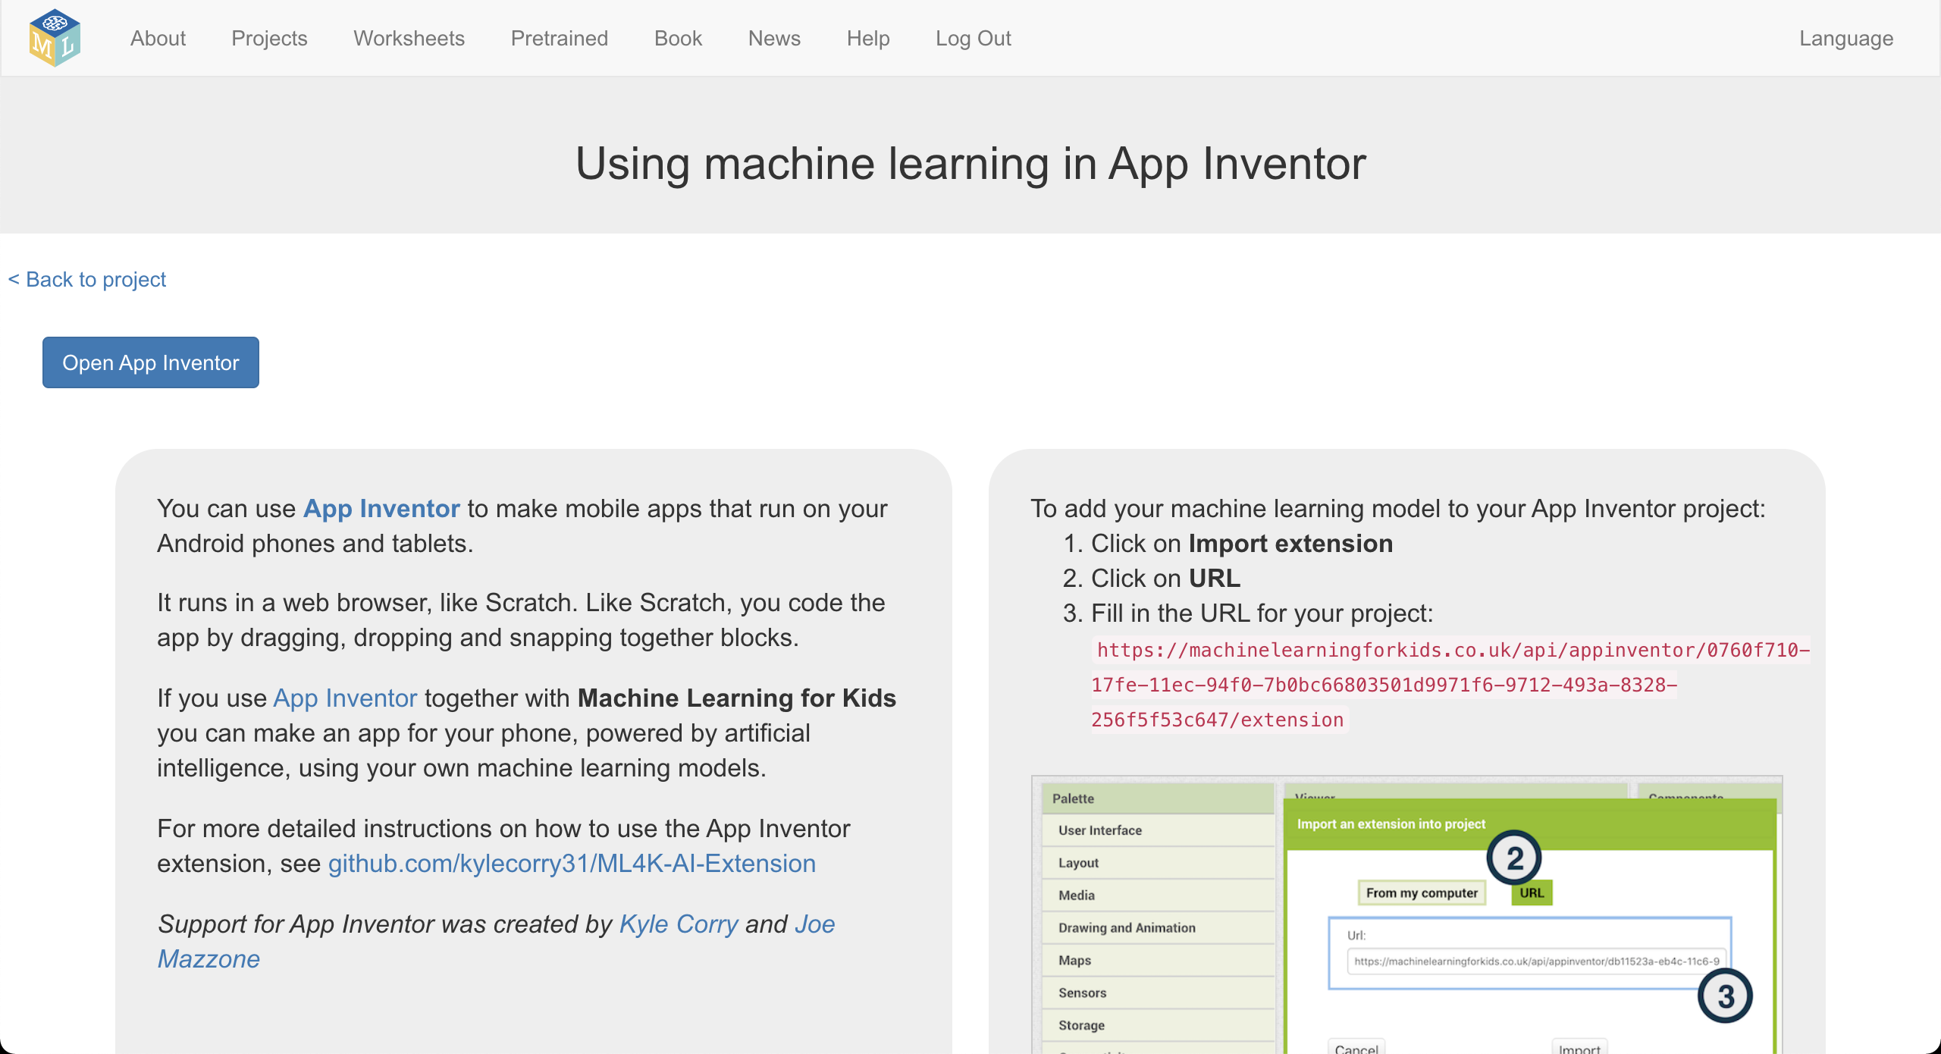
22. In a new web browser window, open the “judgeabook” template in App Inventor using this address:   
    <http://ai2.appinventor.mit.edu/?repo=raw.githubusercontent.com/dalelane/ml4k-appinventor-templates/master/judgeabook.asc>  
      
    *If you’re using a printed copy of this worksheet, use this short address instead:*<https://ibm.biz/ai-template-book>
23. Click on “**Import extension**”  
    Graphical user interface, application

    Description automatically generated
24. Click on the “**URL**” button  
    Paste the address from Step 21 (the red text) into the box  
    Click “**Import**”  
    Graphical user interface, application

    Description automatically generated
25. Drag “ML4KComponent” from the list, and drop it on the phone.  
    *It takes a few minutes for it to appear in the list. Please be patient!*   
    Graphical user interface, application

    Description automatically generated
26. In the Blocks tab, find the “**when btnTrainModel Click**” code and add a **TrainNewModel** block so that it looks like this:  
    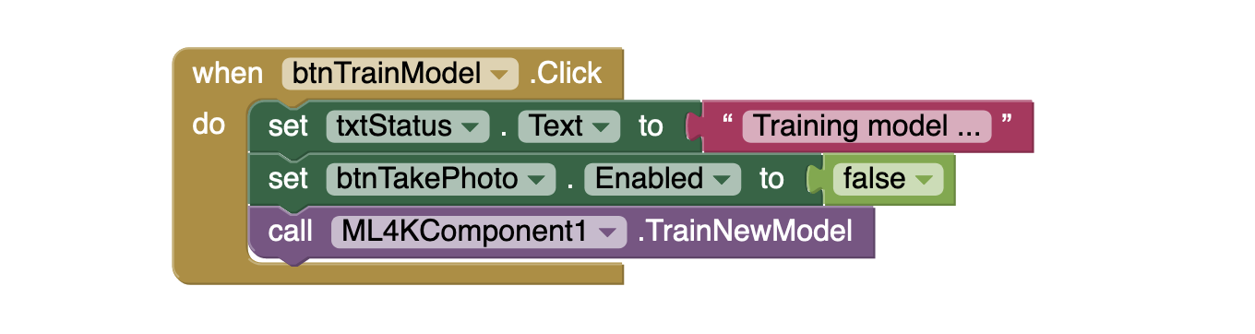
27. Find the “**when btnCheckModel Click**” code and   
    add a **GetModelStatus** block so that it looks like this:  
    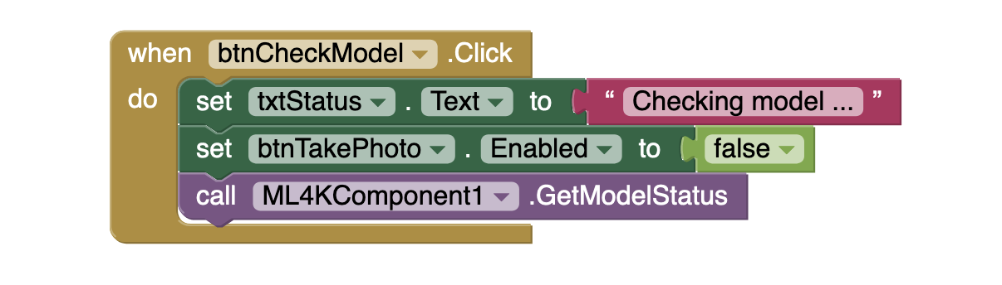
28. Create the following code:  
    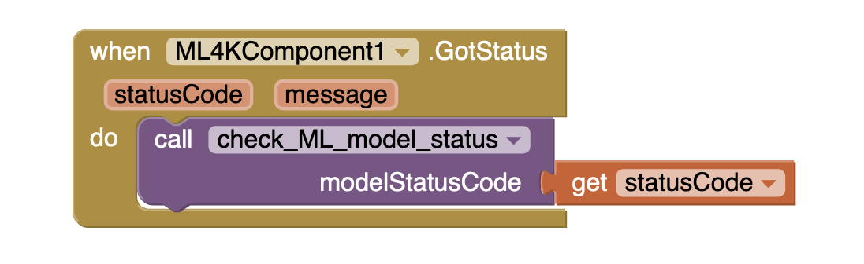
29. Find the “**when Camera1 AfterPicture**” code and   
    add a **ClassifyImage** block so that it looks like this:  
    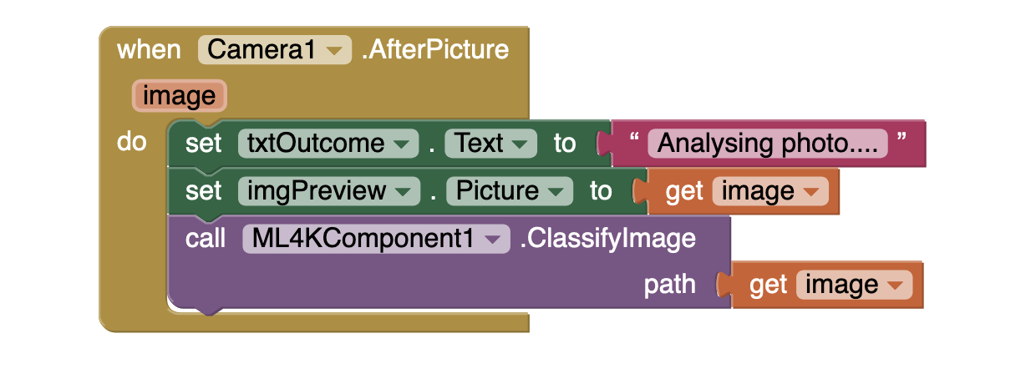
30. Create the following code:  
    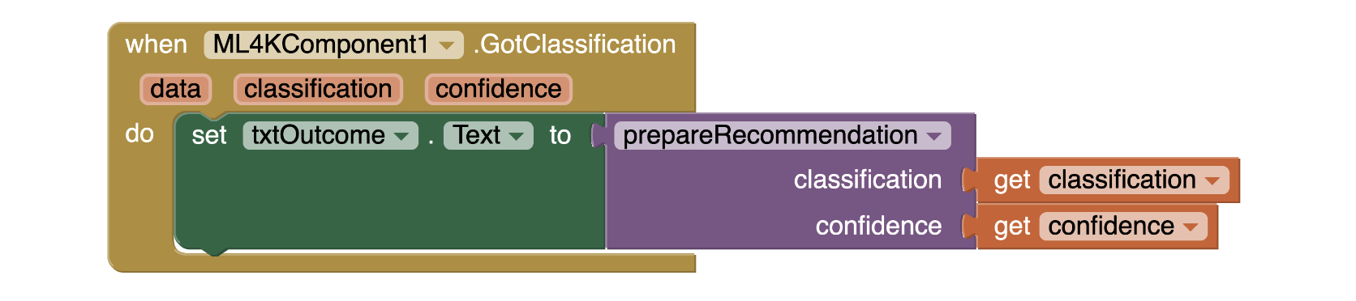
31. It’s time to test!  
    *Deploy the app to an Android device  
    Click on the “Train new machine learning model” button  
    It will take a minute to train – click on “Check” to see if it’s finished   
    When it is ready, click on “Take photo of the next book”  
    Your app will predict what shelf the book belongs on!  
    A picture containing graphical user interface

    Description automatically generated A card with a cartoon child on it

    Description automatically generated with low confidence*
32. Try your app out with a few different books  
    *Are you* *happy with the predictions that it makes?   
    What could you do to improve the predictions that the app makes?*

**What have you done?**

You’ve trained a machine learning model to classify pictures. The computer learned from patterns in the colours and shapes from each of the images you’ve given it. These were used to recognise new covers.

This means your app will be able to predict the best place to put books, even new books that the app has never seen before, without needing any record of that book – other than what the cover looks like.

**Ideas and Extensions**

Now that you’ve finished, why not give one of these ideas a try?

Or come up with one of your own?

**Alternative project ideas**

Instead of book covers, why not try:

* album covers – train a computer to recognise the music genre of an album from a picture of the cover – do pop music albums look different from rap albums?
* movie posters – train a computer to recognise the type of movie based on a picture of the poster – do action movie posters look different from period drama movie posters?